CHEM 1311- Thermochemistry Cont.
Ch.5 Formula Dump:

When 12.0 g of fructose, C₆H₁₂O₆, is burned with oxygen in a calorimeter, the temperature of the calorimeter increases by 2.58 °C. If the heat capacity of the calorimeter and its contents is 9.90 kJ/°C, how much heat was produced by this reaction?

B₂H_{6 (g)} + 3O_{2 (g)} → B₂O_{3 (s)} + 3H₂O_{(l)}
Calculate the enthalpy change for the reaction above using the following data.
2B_{(s)} + 3H_{2 (g)} → B₂H_{6 (g)} ΔH = 36 kJ/mol
H_{2 (g)} + ½O_{2 (g)} → H₂O_{(l)} ΔH = −286 kJ/mol
2B_{(s)} + 1½O_{2 (g)} → B₂O_{3 (s)} ΔH = −1274 kJ/mol

A system does 30.4 kJ of work and absorbs 73.0 kJ of heat from the environment. What is the change in internal energy of the system?

Calculate the energy (E) and wavelength (λ) of a photon of light with a frequency (ν) of 6.165 x 1014 Hz.

C₆H₁₂O₆ _{(s)} +6O₂ _{(g)} 6CO₂ _{(g)} + 6H₂ O _{(l)}
Using the equation above and the relative ∆H values, calculate the change in enthalpy for the overall reaction.
∆H_{f} for the following:
C₆H₁₂O₆ _{(s)} -1260 kJ/mol
CO₂ _{(g)} -393.5 kJ/mol
H₂O _{(l)} -285.8 kJ/mol

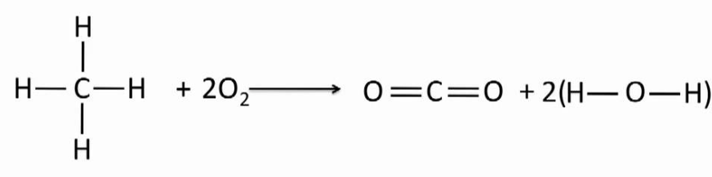
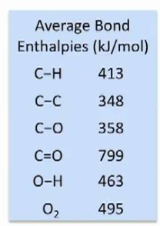
Calculate the enthalpy change for the reaction below using the average bond enthalpy information.

