Steps to solving a mathematical problem relating to gas laws:
- Identify the variables you are given and asked to solve for.
- Determine which formula best fits the variables.
- Rearrange the formula to solve for the appropriate variable.
- Make any necessary conversions (L, atm, g, K)
- Solve using the rearranged formula.
A sample of gas has a volume of 2.5 L at a pressure of 1.2 atm. If the pressure is increased to 3.0 atm, what will the new volume be (assuming the temperature remains constant)?

A gas has a volume of 2.0 L when the pressure is 1.0 atm and the temperature is 300 K. If the pressure increases to 1.5 atm and the temperature rises to 400 K, what will be the new volume?

A gas is stored in a container at a pressure of 2.0 atm and a temperature of 300 K. If the container is heated until the temperature reaches 450 K, what is the new pressure (assuming the volume stays constant)?

A gas occupies a volume of 5.00 L at a pressure of 2.00 atm and a temperature of 300 K.
How many moles of gas are in the sample?

The density of an unknown gas is 1.96 g/L at STP (1.00 atm and 273 K). What is the molar mass of the gas?

A balloon has a volume of 2.0 L at a temperature of 300 K. If it is heated to 450 K (and the pressure stays constant), what will the new volume of the balloon be?

Review the postulates of the kinetic molecular theory:

The average kinetic energy of all gas molecules is ______________, so gas particles of smaller mass must have a _______________ speed, and gas particles of larger mass must have a ______________ speed.
Label each example as effusion or diffusion:
- Air leaking from a tire puncture ________________
- Perfume bottle with a tiny nozzle __________________
- Fragrance scent released into an open room _________________
- Smelling food from another room _________________
Graham’s Law formula:
Hydrogen gas and an unknown gas are placed in separate containers with tiny pinholes. If hydrogen effuses through its container 4 times faster than another unknown gas, what is the molar mass of the unknown gas?
List and describe each of the intermolecular forces.
- London dispersion

- Dipole-dipole

- Hydrogen bonding

- Ion-dipole
Steps to identify the types of intermolecular forces present in a molecule:
- Draw a Lewis structure to determine its overall polarity and bonds.
- Check for hydrogen bonding (H-FON).
- Check for dipole-dipole forces (is the molecular polar but lacks hydrogen bonding?).
- Confirm London dispersion forces.
Use the steps listed above to determine the types of intermolecular forces present in the following molecules.
CH₃OH  ______ Hydrogen bonding  ______ Dipole-dipole forces  ______ London dispersion forces | SO₂  ______ Hydrogen bonding  ______ Dipole-dipole forces  ______ London dispersion forces
CO₂  ______ Hydrogen bonding  ______ Dipole-dipole forces  ______ London dispersion forces | NH₃  ______ Hydrogen bonding  ______ Dipole-dipole forces  ______ London dispersion forces

Define the following properties of liquids that are affected by intermolecular forces.
- Boiling point-
- Melting point-
- Surface tension-
- Capillary action-
- Viscosity-
Name each transition below:

SG _______________________
SL _______________________
GS_______________________
GL_______________________
LG_______________________
LS________________________

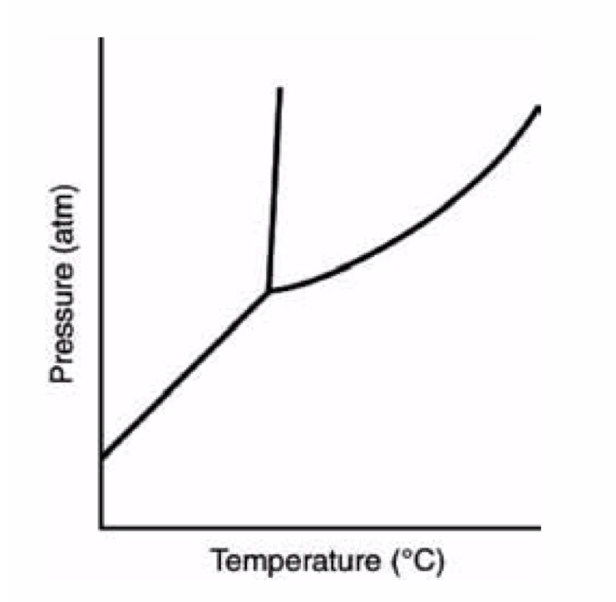
In the following Pressure vs. Temperature diagram, identify the triple point and which regions represent a solid, liquid, and gas phase.

