|  |  |
| --- | --- |
| 1. | 2. |
| 3. | 4. |
| 5. | 6. |
| 7. | 8. |
| 9. | 10. |
| 11. | 12. |

Did you hear the joke about cobalt, radon, and yttrium?

_ _ _ _ _ _ _ _ _ _ _ _ .



1 2 3 4 5 6 7 8 9 10 11 12

Chem-1311 Chapter 1 Worksheet 9/3

Describe the key differences between physical and chemical properties of a substance.



Fill in the blanks with the SI metric unit for each measurement.

Volume _____________



Mass _____________

Length _____________

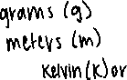

Temperature ____________

Amount of substance ____________



Which of the following masses could be weighed on a scale that ranges from 5-150kg?

1. 2.3x105 g



1. 2.3x104 g



1. 2.3x103 g



The density of copper is 8.96 g/cm3. What is the mass of a cube of copper that is approximately 8.00 cm on each side?

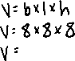

An object has a mass of 0.00190330g. How many significant numbers does this digit have?



Describe the movement of molecules in a solid substance? In a gas?

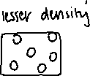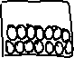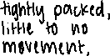

Solve the following problem using correct significant figures.

(1.304 + 24.36) ÷ (3.006 x 0.00238)



An exothermic reaction reported a change in temperature of 18.3oC. What is the change in temperature in Kelvins?



Which of the following is an example of a chemical change?



1. Compression of a gas
2. Evaporation of a liquid

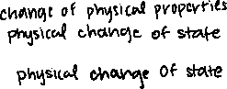

1. Combustion of a gas



1. Condensation of a vapor

Which of the following is an example of a pure substance?

1. Air



1. Baking soda



1. Ocean water



1. Juice concentrate

Round the number off to three significant figures: 0.00850043 _______________________



Round the number off to four significant figures: 2,456,900 _______________________



A scientist is using propane and finds that it has a density of 36.28lb/ft3. He needs to report it in metric units. What is the density in kg/m3? (1 lb = 454g, 1 in = 2.54cm)

