Chemical Structures, Hybridization, and Molecular Orbital Theory
~For questions 1-8, be able to prove why your selected answer choice is correct and why your unselected answer choices are incorrect.
1. If a structure has 1 lone pair and 3 bonding pairs, what is the correct electron geometry and molecular geometry pair?
- Tetrahedral: Trigonal Bipyramidal
- Trigonal planar: Linear
- Tetrahedral: Tetrahedral
- Trigonal planar: Bent

2. What is the polarity of a H₂S molecule?
- Polar because the lone pairs consume more space and creates a partially negative side
- Non-polar because the molecule and its arrangement of electrons has symmetry
- Non-polar because having all non-polar bonds indicate a non-polar structure
- Polar because bonding pairs are more electronegative than lone pairs

3. What is the polarity of a CNS molecule?
- Polar because there are different elements on either side of the central atom
- Non-polar because the structure demonstrates resonance
- Polar because there is a difference in electronegatively on each side of the central atom
- Non-polar because it is a linear structure with symmetry

4. Which statement is true regarding bond angle relationships in a Lewis structure?
- Tetrahedral structures form right angles because they have four electron domains surrounding the central atom.
- The existence of lone pairs increases all the other bond angle measurements within a structure.
- In decreasing order of electron domains, the corresponding order of angle degree measurements is 180, 120, 109.5.
- An angle involving a multiple bond is greater than an angle with a single bond.

5. Molecular geometry describes the _______________ of a Lewis structure.
- Arrangement of electrons
- Three-dimensional shape
- In-depth description
- Bonding pattern
6. Hybridization describes the ________________ of a Lewis structure.
- Arrangement of atomic orbitals
- Molecular shape
- Arrangement of electron domains
- Variation

7. Which statement is false regarding hybridization.
- The molecule HF has a hybridization of sp.
- Hybridization requires at least two electron domains.
- The Aufbau principle is applied to understanding how s and p orbitals are filled.
- The formation of hybrid orbitals may require the promotion of an electron from an s orbital to a p orbital.

8. Which statement(s) are true about sigma and pi bonds?
- Pi bonds are generally weaker than sigma bonds
- A single bond is a pi bond
- Sigma bonds are head-to-head overlap while pi bonds are side-to-side overlap

- II only
- I, II
- I, III
- All are correct

9. Draw the Lewis structure for the following molecules and state their hybridization.

CO₂

NO₂⁻

Define the following:
Sigma orbital
Pi orbital
Bonding molecular orbital
Antibonding molecular orbital
Diamagnetism
Paramagnetism
Draw the MO diagram for F₂, F₂ ²⁺, and F₂ ²⁻, then calculate the bond order for each.
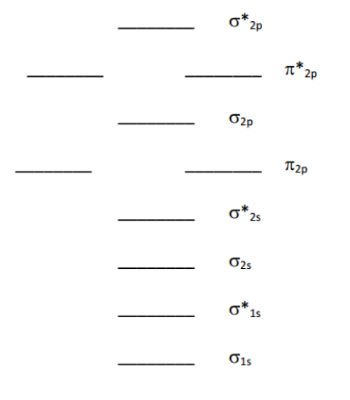

Refer to the MO diagrams above. According to molecular orbital theory, which of the following lists ranks the fluorine species in terms of increasing bond order?
a. F₂ ²⁻ < F₂ < F₂ ²⁺ b. F₂ ²⁺ < F₂ ²⁻ < F₂ c. F₂ < F₂ ²⁻ < F₂ ²⁺ d. F₂ < F₂ ²⁺ < F₂ ²⁻

