Unit 3 Test Prep- Ch.7-9
- Match the following trends to their definition
- Atomic Radii
- Electronegativity
- Ionization Energy
- Electron Affinity
- Ionic Radii
_______ Half the distance between the nucleus of two identical atoms in a bond.
_______ The energy required to remove an electron from an ion.
_______ The distance from an ion’s nucleus to its outermost electron.
_______ The energy change when an atom gains an electron to become a negative ion.
_______ The tendency of an atom to attract a pair of electrons.
- Which of the trends listed above increase along the rows from right to left and along the columns from top to bottom?

- Which of the trends listed above increase along the rows from left to right and along the columns from bottom to top?

- What is the correct order for increasing atomic radius for the elements Mg, Na, P, Si, and Ar?

- What is an isoelectronic series? Provide an example in your explanation.

- What is effective nuclear charge? Include the formula in your answer.

- Draw the Lewis structure for the following compounds and identify if it is covalent/ionic.

SO₂ | N₂
MgBr₂ | CH₄

- Write the formula for calculating the formal charge of an atom in a covalent Lewis structure.

- What is resonance?

- Determine which of the following compounds has resonance and draw all possible configurations.
- CO₂
- H₂O
- O₃
- NH₃

- Describe the difference between bond polarity and molecular polarity.

- What is the mathematical scale used to determine polarity when calculating the difference in electronegativity between 2 atoms?

- Why can a molecule contain polar bonds but still be nonpolar overall? Give an example of a compound that demonstrates this idea.

- How does symmetry affect whether a molecule is polar or nonpolar?

- Which of the following bonds would be hardest to break due to its polarity and bond strength? (Electronegative values: H=2.1, C=2.5, N=3.0, O=3.5, F=4.0)
- C-H
- N-H
- O-H
- F-F

- Explain the difference between electron geometry and molecular geometry.

- What is the molecular geometry for the following compounds based on their descriptions?
  - 3 single bonds; 1 lone pair ______________________________
  - 1 bond; no lone pairs ______________________________
  - 1 single bond & 1 double bond; 1 lone pair ______________________________
  - 2 double bonds; no lone pairs ______________________________
  - 4 single bonds; no lone pairs ______________________________

- What is a dipole moment?

- Draw an s, p, and sp orbital, then draw a visual example of a sigma and pi bond.

- What is the formula for calculating bond order and what does it conclude?

- Explain the difference between diamagnetism and paramagnetism.

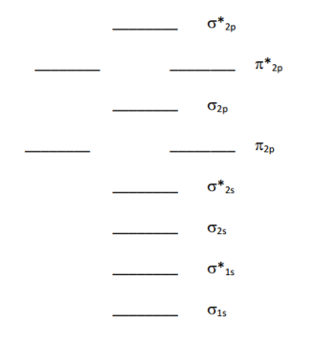
- Complete the molecular orbital diagram for O₂ and calculate the bond order. What is its magnetism?

